Topic : spendwise
Team number:05
Team head:
HARSHINI. R
CD6C02C3D8435D9A5424FC39C1383460
Team members :
DIVYA S
EEA9686492C906FB88044700470BE272
DURKA S
E7A8CA55BD2E501825E4E9DDFC772F9F
GOBIKA. R
3277278D9135D4D96F24ACC40CEEBEC7

Abstract
Personal finance management is important in today's digital world where people perform many financial transactions daily. Expense tracking applications help users monitor income, expenses, and savings.
SpendWise is a backend-based expense tracking application developed using Node.js, MongoDB, and JSON Web Tokens (JWT). The system allows users to register, log in, record expenses, and manage financial transactions securely.
The project demonstrates important backend concepts such as REST API development, database management, authentication, and secure data handling. It serves as a learning platform for students and developers who want to understand how financial applications manage user data efficiently.

1. Introduction
Managing personal finances is essential for maintaining financial stability. With the rise of digital payments and online transactions, it has become difficult for individuals to track their expenses manually.
Expense tracking applications help users record and analyze their spending habits. Popular applications such as Mint and YNAB provide these services.
SpendWise is developed as a simple backend learning project that demonstrates how financial data can be managed using modern web technologies.
The main technologies used are:
Node.js – Server-side development
Express.js – API routing
MongoDB – Database storage
JWT – User authentication
The system allows users to register, log in, add expenses, and view transaction history securely.

2. Objectives of the Project
- The main objectives of SpendWise are:
- To design a backend system for managing personal expenses.
- To implement secure authentication using JSON Web Tokens (JWT).
- To develop RESTful APIs for expense management.
- To demonstrate database operations using MongoDB.
- To help students understand backend development concepts.
Additional objectives include:
- Learning Node.js server architecture
- Understanding NoSQL data modeling
- Implementing secure authentication systems
- Managing user financial data efficiently

3. Literature Review
Several studies and research works have examined personal finance management systems and financial technology applications.
Talathi (2025) developed a prototype expense tracker system that improves financial transaction management.
Stefanov et al. (2024) highlighted that digital finance applications help users analyze their spending behavior and improve financial awareness.
Bitrián, Buil, and Catalán (2021) explained that gamification in finance applications increases user engagement and encourages better saving habits.
Carlin, Olafsson, and Pagel (2021) studied financial technology adoption and identified security, trust, and usability as key factors.
Alenazi (2023) emphasized the importance of secure authentication and efficient database management in financial applications.

4. System Architecture
The SpendWise system follows a client-server architecture.
Components of the system:
- Client Application
- Backend Server
- Database
The client sends requests to the backend server through REST APIs. The backend processes the request and interacts with the MongoDB database to retrieve or store information.

5. Technologies Used
Node.js
Node.js is a JavaScript runtime environment used for building scalable server-side applications. It enables developers to use JavaScript for backend development.
Express.js
Express.js is a lightweight web framework for Node.js that simplifies API development and request handling.
MongoDB
MongoDB is a NoSQL database that stores data in JSON-like documents. It provides flexibility and scalability for modern web applications.
JSON Web Token (JWT)
JWT is used for secure authentication. It allows the server to verify user identity without storing session data.
Mongoose
Mongoose is an Object Data Modeling (ODM) library used to manage MongoDB data structures in Node.js.

6. Database Design
The database stores two primary types of data:
- User Information
- Expense Transactions
User Schema
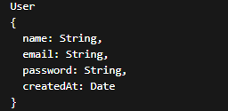
Expense Schema
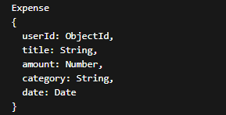

7. API Design
SpendWise provides several REST APIs.
User Authentication APIs
Method | Endpoint | Description
POST | /register | Register new user
POST | /login | Login user
GET | /profile | Get user profile

Expense Management APIs
Method | Endpoint | Description
POST | /expenses | Add new expense
GET | /expenses | Get all expenses
PUT | /expenses/:id | Update expense
DELETE | /expenses/:id | Delete expense
8. Implementation
The backend system is implemented using Node.js and Express.

Server Setup Example
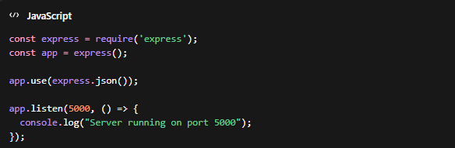

JWT Authentication Example
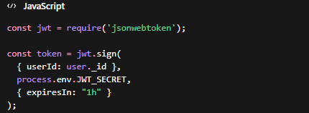
JWT tokens are generated when the user logs in and must be included in future API requests.

9. Security Mechanisms
Security is an important part of financial applications.
SpendWise implements the following security measures:
- Password hashing using bcrypt
- Token-based authentication using JWT
- Protected routes using middleware
- Input validation for API requests
These techniques help protect user data and prevent unauthorized access.

10. Testing
The APIs were tested using tools such as:
- Postman
- REST client tools
Testing ensures that all endpoints work correctly and handle errors properly.
Example test cases include:
- User registration validation
- Login authentication
- Expense creation
- Expense retrieval
11. Advantages of SpendWise
- Simple backend learning project
- Demonstrates modern web development practices
- Secure authentication using JWT
- Scalable database using MongoDB
- Useful for learning REST API development

12. Limitations
The project also has several limitations:
- No advanced analytics features
- No budgeting tools
- No mobile application interface
- Limited data visualization
Future improvements can address these limitations.

13. Future Enhancements
Several features can be added in the future:
- Expense analytics dashboard
- Budget planning system
- Mobile application integration
- AI-based financial recommendations
- Gamification features for saving goals

14. Conclusion
SpendWise demonstrates the development of a basic backend expense tracking system using Node.js, MongoDB, and JWT.
The project helps developers understand important backend concepts such as authentication, API development, and database management. Although simple, SpendWise provides a strong foundation for building more advanced financial applications.l

